**Practical session 2**

*For the practical part of this lab please save the Python programs that you create and take screenshots of the execution (evaluation) of your programs.*

**Tasks:**

1. Write an algorithm that describes how to make scrambled eggs, try to use control words, like IF, WHEN, UNTIL, WHILE, WAIT, AND, OR.

Algorithm:

-Beat eggs, milk, salt and pepper in a bowl until blended

- Heat butter in large non-stick skillet over medium heat until hot.

- When eggs begin to set, GENTLY PULL the eggs across the pan with an inverted turner, forming large soft curds.

1. Is Idle (the Python language shell) an Interpreter or a Compiler or both? Explain your answer.

Python is an interpreter language as its reads at the time of execution and each statement is executed as it reads. While a compiler language is one which is read, translated into machine code (or bytecode) and then saved into that format to be executed later.

1. Write a command in the Idle shell that says “Hello world”

c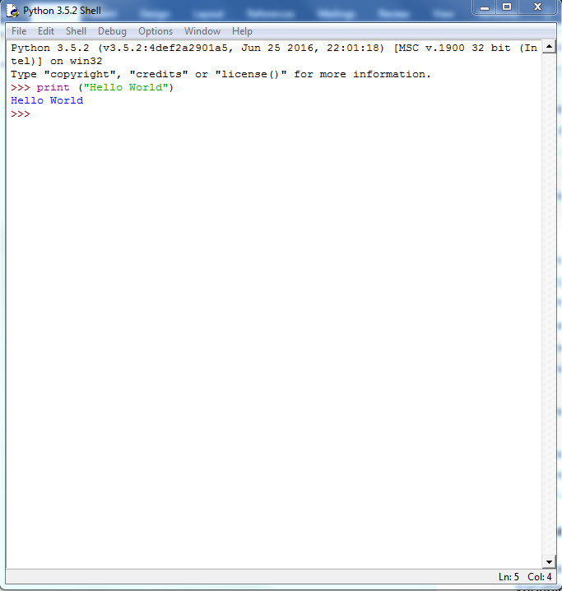

4) Write a program that produces the following output:

Hello World

I am in my ISD class right now

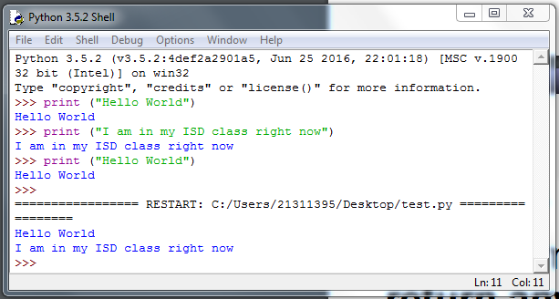

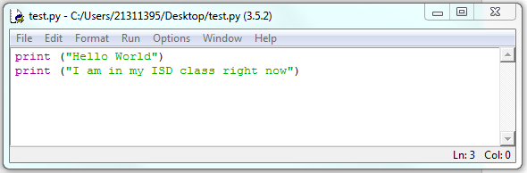

**Reminder on “Input”:**

A simple way to store variables (values) in your program is to use variables. Variables are placeholders that can store values, like strings (words), numbers (int) etc.

To create a variable, just give it a name and an initial value, for example for a number:

number = 7

or for a String (words):

myword = “This is my word”

5) Write a program that asks the user for his/her name and produces an output like:

Hi there, what is your name?

>User input to be read<

Hello

“User name”

How are you?

